PeriWatch Anti-Virus Exclusion List and Open Port List
Takeaways:
- If not properly set up, AV can negatively impact system performance or basic functionality.
- If not properly set up, Web Proxies or Filtering Software can negatively impact system performance.
(note that HillRom/WatchChild may now be PeriGen/PeriWatch)

ALL Antivirus Software
Antivirus software can degrade performance or interfere with operation of both our client and server software. Real-time scans on our production server can slow down our database access, and scheduled scans can consume dangerous amounts of system resources. Additionally, files can be locked while they are scanned, which can interfere with some parts of the application.
On the server, exclude antivirus scans to follow the directory locations (including all subdirectories).
Note: Drive Directories may differ due to the location you have installed PeriWatch on your Server. The folder names are subject to change. If you have issues locating any of the folders, please let us know.
  - D:\Program Files\Microsoft SQL Server
  - D:\Program Files\Orion Health
  - D:\Program Files (x86)\Orion Health
  - D:\Perigen\PeriWatch
C:\windows\IIS Temporary Compressed Files
C:\windows\system32\inetsrv
C:\pagefile.sys (could be on the D: drive)
C:\inetpub
C:\NNB_HL7
C:\NWCLOGS
C:\ArchivingExportFolder
E:\Program Files\Microsoft SQL Server
F:\Program Files\Microsoft SQL Server
G:\Program Files\Microsoft SQL Server
\PeriWatch\Archive
On the server and each workstation, exclude antivirus scans to the following directory locations.
C:\PeriGen\*

ALL Web Proxy/ Filtering Software or Services
If they are not configured to ignore our applications traffic, web proxies can incorrectly view our internal communications as internet browsing, and silently route those communications through their proxy server. This will always impact our application’s performance and can result in failure and errors due to blocked or mishandled communication.
Confirm that the web proxy’s configuration is set to ignore traffic to the IP addresses and host names of our production and testing and training servers.
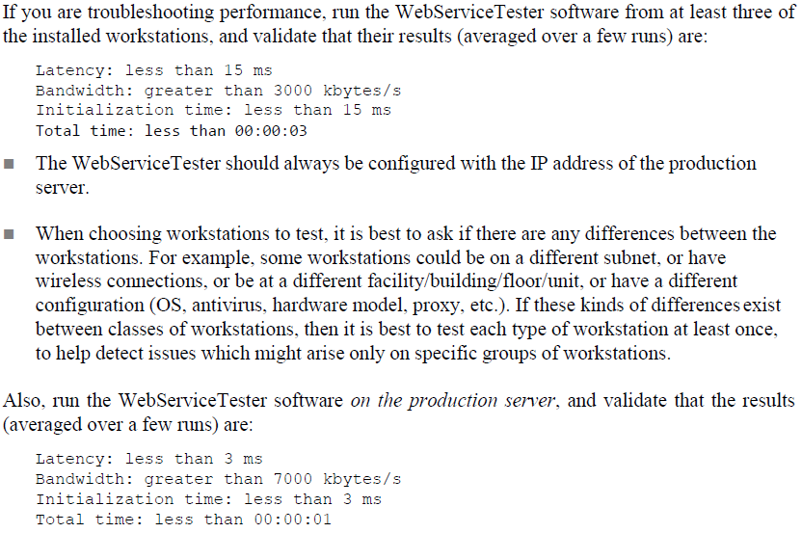

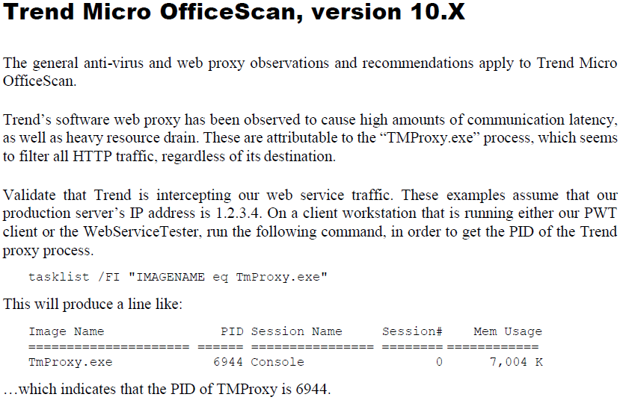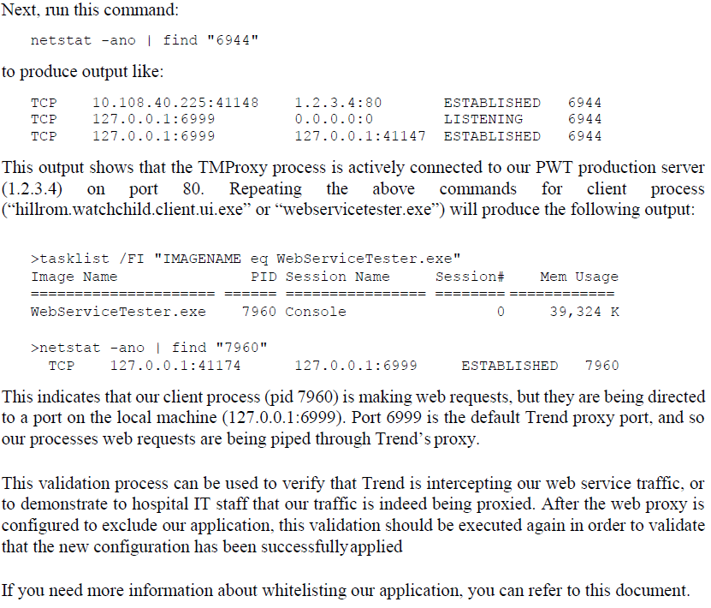
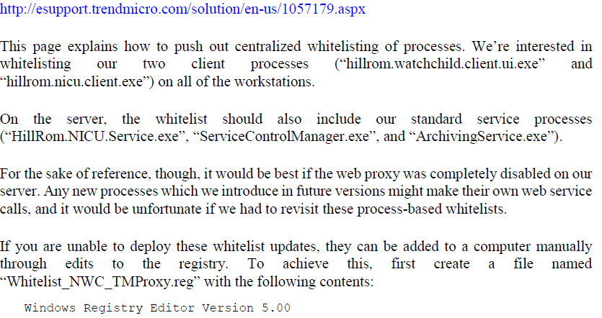
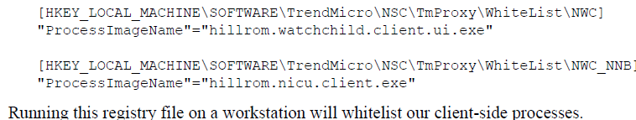
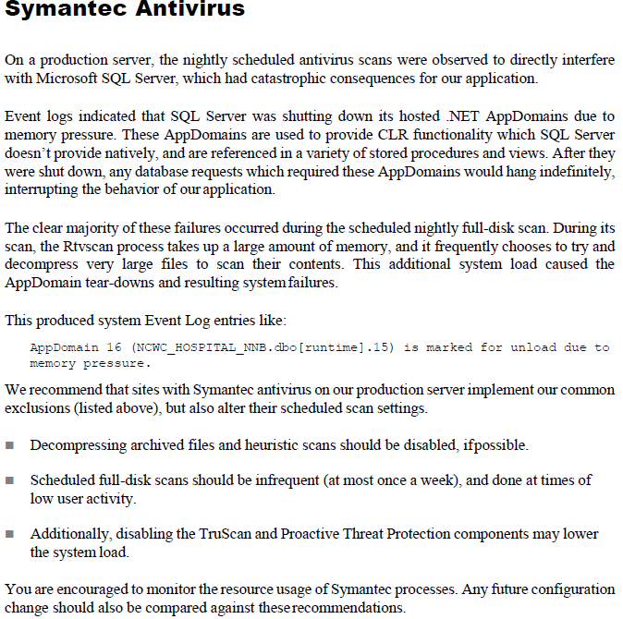
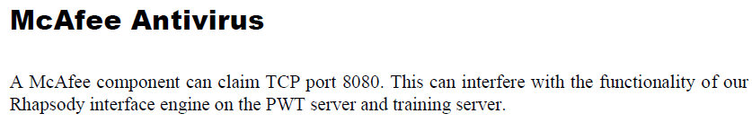
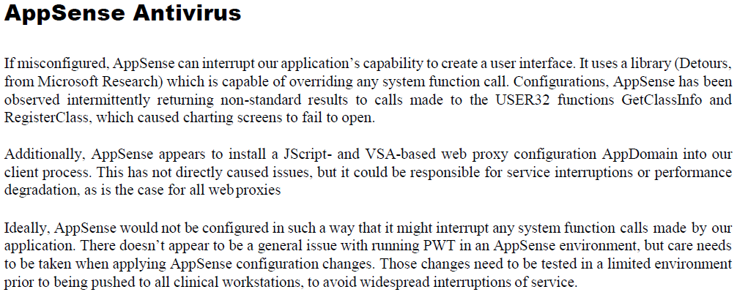
  - Additionally, if a hostname-based whitelist is available in any web proxies, it is recommended that they be configured to whitelist all the IP addresses and host names assigned to our server.
Process Exclusions from Anti-Virus or WebProxy
We require exclusion of the following processes from Anti- Virus or WebProxy:
servicecontrolmanager.exe (D:\Perigen\PeriWatch\Server)
  - PeriWatch.Newborn.Client.exe (D:\Perigen\PeriWatch\NNBClient)
  - archivingservice.exe (D:\Perigen\PeriWatch\ArchiveService)
reportingservicesservice.exe (D:\Program Files\Microsoft SQL Server\MSRS12.HRNWC2014\Reporting Services\ReportServer\bin)
  - w3wp.exe
  - sqlservr.exe (D:\Program Files\Microsoft SQL Server\MSSQL12.HRNWC2014\MSSQL\Binn)

Process Exclusions from Workstations
We require exclusion of the following processes on the Workstations:
PeriWatch.Tracings.Client.UI.exe (E:\Perigen\PeriWatch\NWCClient)
PeriWatch.Newborn.Client.exe (E:\Perigen\PeriWatch\NNBClient)
Workstation Port Exclusion: AutoDeploy FS/ NWCConfigData.xml
RhapsodyMonitor.exe (D:\Program Files\Orion Health\Rhapsody\bin)
ReportBatchProcessor.exe (E:\Perigen\PeriWatch\Services\ReportBatchProcessor)
SQLAGENT.exe (D:\Program Files\Microsoft SQL Server\MSSQL12.HRNWC2014\MSSQL\Binn)
Sqlbrowser.exe (C:\Program Files (x86)\Microsoft SQL Server\90\Shared)
Sqlwriter.exe (C:\Program Files (x86)\Microsoft SQL Server\90\Shared)

Ports required by PeriWatch components:
TCP Port # Description
80 iisHTTPPort
8000 DASTCPPort
8001 mexNetTCPDuplexPort
8002 ClientVitalsTCPPPort
8003 mexNetTCPRequestResponsePort
8004 EBSTCPPort
8005 basicHTTPPort
8006 netTCPDuplexPort
8007 netTCPRequestResponsePort
8008 webHTTPPort
8009 MessageReceiverDispatcherTCPPort
8010 DASDataRedundancyTCPPort
8011 Reserved
8012 Reserved
8013 Reserved
8014 EBSSecureTCPPort
8015 Reserved
8015 Reserved
8016 Reserved
8017 Reserved
8018 Reserved
8019 Reserved
8020 Reserved

UDP Port # Description
11002 TimeSyncUDPPort

*Port 80 for HTTP
*Ports 8000-8020 for TCP
*Port 11002 UDP

